Proceedings in  MANUFACTURING SYSTEMS | Proceedings in Manufacturing Systems, Vol. 5 (2010), No.

BEVELLING OF RIB CAGE ON TAPERED ROLLER BEARING

Anton PANDA¹, Jozef JURKO² Iveta PANDOVÁ³, Tadeáš KURILOVSKÝ⁴

Abstract: Raising output of bearings in past years in one bearings firm was not feasible solution extensive way – so increase the quantity of producer machines near equal productivity of labour. This problem to have been needs solve, on scores of sector production its ayay. On working of cage production on some operation was she productivity of labour least. And so there was needs to realize development of new tool. Concrete on operation bevelling ribcage cage, for development tool on bevelling ribcage cage suddenly – on one heave of compactor. To development period of new tools oneself bevelling ribcage cage was executing like this, that on 1 heave compactor oneself run over only edge on 1 ribcage.

Key words: Tools, bearing, cage, rib, beveling, rollers.

1. INTRODUCTION. MANUFACTURING OPERATION - BEVELLING RIBCAGE OF CAGE

Aim of operations is to create saddle for roller in bearing and provide for cage sufficient radial clearance. On operation are accordingly installed half-round high-speed tilting compactor, in workspace those oneself fixture working tool (fig. 1). Principle bevelling ribcage of cage inhere in pressing ribcage of cage through the medium punch knife clamping work in hammer block of compactor to selection in matrix clamping work in stand. Stand is attached to basic board of compactor. Thereby arrive to bevelling inner lengthwise edges of cage, whereby oneself creates saddle for roller (fig. 2).

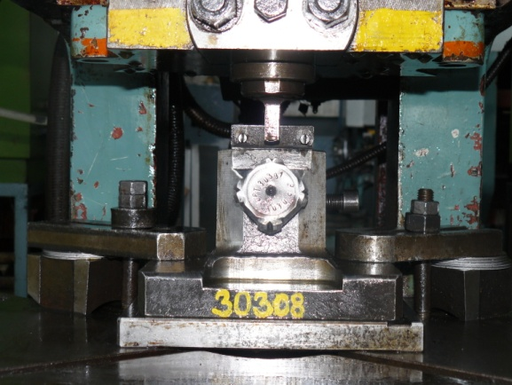

Fig. 1. Tool on bevelling ribcage of cage

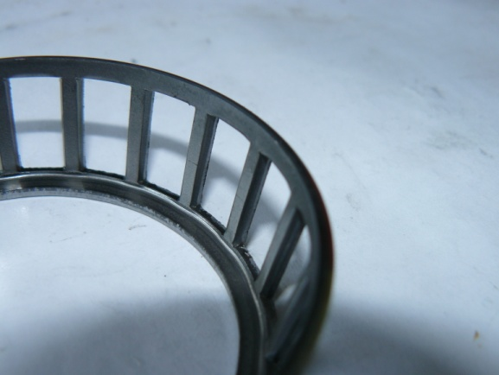

Fig. 2: Cage with bevelling ribcage

2. PRIMARY (PREVIOUS) TOOLS

Is concerned about tool, which was standardly used and is used for bevelling ribcage of cage tapered roller bearings. Was caused by primary equipped technology after shoping of compactors on this operation after worked-out construction and technological documentation for bearings. It is bipartite tool of simple construction, non-exigent pintle guide on top and down sections of tool by leading peg (fig. 1).
Clamping work tool in machine oneself realize in top sections through the medium socket punch knife in hammer block of compactor, in down sections clamping work holder with matrix through the medium clamping work. Principle of beveling of edge rests in pressing ribcage of cage by punch knife into cut-out of matrix. By turn of cage to the next rib oneself cycle is repeat. Tool oneself unload from punch knife, matrix and holder.

2.1. Punch knife

Part is produced from tool steel, he is hardening and temperability on 60 HRC (fig. 3). In her active sections is possible her grinding by need settings swerve beveling of cage.

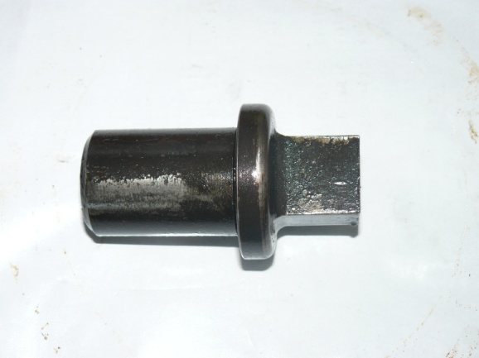

Fig. 3. Punch knife

2.2. Matrix

Part is accordingly produced from tool steel, hardening and temperability on 60 HRC. In his active sections has 4 cut-out, positioner below angle 90°, what allows in case damage one's cut-out to use following good (fig. 4). At cut-out is grinding angle, below who're bevelling edges ribcage of cage. Matrix oneself is fixture in holder in his back square pillar sections by the medium screw.

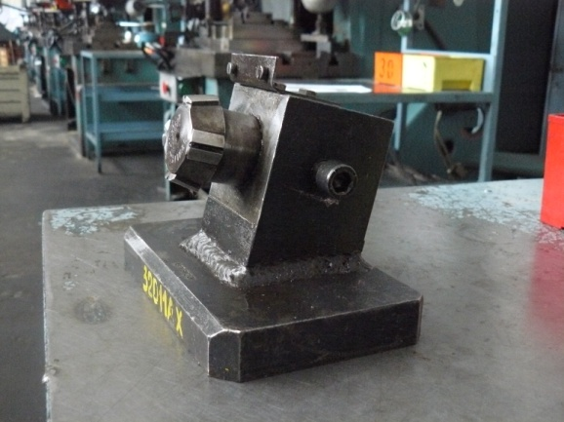

Fig. 4. Holder with matrix

3. TOOLS ON BEVELLING RIBCAGE OF CAGE SUDDENLY, ON 1 HEAVE

Tool was developed because of hike effectiveness production cage after grow of production and growth qualities of cage. It is bipartite tool controlled leading peg, where in down sections of tool oneself find on expansion cone punch knife. Those are holding from down by beneath spring and by ring, from top press tablet. In top section of tool it is set die hammer (fig. 5).

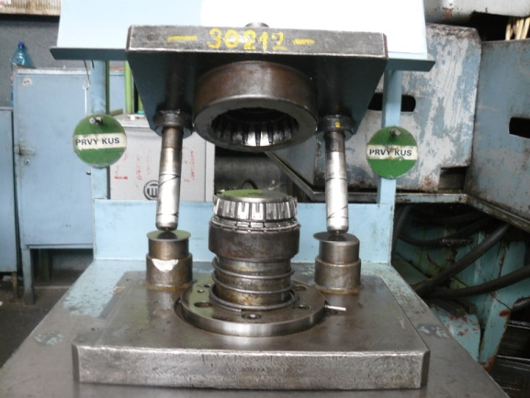

Fig. 4. Holder with matrix

Cage oneself put on punch knife and in one cycle of compactor die hammer, in down caputium ram, push back on rib of cage, on those punch knife bevelling edges.

4. EXAMINATION OF BOTH TOOLS

4.1 Primary tool

Advantages of tool:
- low acruistion price – 750,- €
- operational by type cast of machine on shopfloor.

Disadvantages of tool:
- advanced waste,
- impossibility corrections possible deformation of cage, native from operation cutting small windows (ovality),
- highes claim to manual skillfulness of worker,
- lower rank of job security.

4.2 Tool on bevelling ribcage of cage on 1 heave

Advantages of tool:
- low waste,
- possibility corrections of possible deformation of cage native from operation cutting small windows (ovality),
- lower claim to manual skilfulness of worker,
- higher rank of job security,
- operational by type cast of machine, because it is cassette tool.

Disadvantages of tool:
- his acruistion price – 9500,- €

5. RESULTS OF EXAMINATION

New tool is of the essence complex tool how primary (original), therefore naturally his acruistion price is higher. But she is compensating with low waste, lower claim to manual skillfulness of worker, higher rank of job security and possibilities corrections deformation from operation cutting small windows, at which operational type cast machine is in good condicion. And so by consider all economic indexs is preferable to produce and use this tool on bevelling ribcage of cage suddenly for maximum number type of bearings.

REFERENCES

[1] A. Panda, J. Jurko, I. Pandová, J. Zajac: Development, produce and testing of new parts for automotive industry. 1. teil. Monograph, FVT TU Košice with seat in Prešov, 2009, 67 p., ISBN 978–80–553–0149–5.
[2] A. Panda, J. Jurko: Replacement technology bevelling cage suitable technology. Ecology of Borderland - EB-08, Monograph, ESE Gorzow Wlkp. - Lagov, 2008, p. 197 – 200, ISBN-13-978-83-925108-5-7.
[3] A. Panda, J. Jurko, I. Pandová: Technology of tapered rollers bearings. Production of bearing cage and rollers, assembling. The question of public safety, ZWSaHFM im. Jana Pawla II.-Zielona Gora, 2009, s.120-123, ISBN 978-83-89932-04-
[4] K. Monková, M. HATALA, R. Čep: Step NC in Relation to the Manufacturing Data Fflow. Sborník vědeckých prací VŠB-TU Ostrava, řada strojní. 2007, roč. LIII, č. 1, s. 135 – 140. ISSN 1210–0471.
[5] BRYCHTA, J.- ČEP, R.- PETŘKOVSKÁ, L.- NOVÁKOVÁ, J.: Summary of Cutting Tool Materials and their Selection. In. CEEPUS Science Report CII-PL-0033-01-0506 – Development od Mechanical Engineering as a Tool for Enterprise Logistics Progress. Poznan : Poznan University of Technology, 2006, p. 51 – 57. ISBN 83–89873–28–1
[6] ČEP, R.- HATALA, M.: Selection of Cutting Tool Materials. Sborník vědeckých prací VŠB-TU Ostrava, řada strojní. 2006, roč. LII, č. 1, s. 23 – 28. ISSN 1210–0471.
[7] KOLLÁROVÁ, Marta - RAGAN, Emil - RIMÁR, Miroslav: Určenie vzťahov pre kontrolu procesu plnenia formy pri liatí kovov pod tlakom. In: Acta Mechanica Slovaca. roč. 12, č. 1-a (2008), s. 291-296. ISSN 1335-2393.
[8] Leššo, I.-Flegner, P.-Šujanský, M.-Špak, E.: Research of the possibility of application of vector quantisation method for effective process control of rocks disintegration by rotary drilling. In: Metalurgija (Metallurgy) 1, vol. 49, Croatian Metallurgical Society (CMS) Zagreb, January/March 2010, s. 61 – 65, ISSN 0543-5846.
[9] Lukovics, I. – Lukovics, P.: High-Power Grinding. In: ICMP 2003, International Congres of Precision Machining, Procedings, CVUT Praha, 2003-09-03/06, p.201-208, ISBN 80-01-02795-3
[10] MONKOVA, K.- HATALA, M.- ČEP, R.: Step NC in Relation to the Manufacturing Data Fflow. Sborník vědeckých prací VŠB-TU Ostrava, řada strojní. 2007, roč. LIII, č. 1, s. 135 – 140. ISSN 1210–0471.
[11] MRKVICA, I. a MORAVEC, V. Funktionsvergleich von VHM-Bohrergeometrie. In: Science Report Project PL- 007 Modern Metrology in Qaulity Management Systems. Kielce: Kielce University of Technology, 2006, p.181-188. ISBN 978-83-8906-66-4.
[12] MRKVICA, I. Application of Coated Cemented Carbides at Hardened Gear Cutting. In: The International Congress MATAR PRAHA 2004, Section 4 Machining and forming processes. Praha : ČVUT Praha, 2004, s. 213-216. ISBN 803421-4-0.
[13] NESLUŠAN, M. - CZÁN, A.: Brúsenie ložiskovej ocele 14 208.4, Strojárstvo 1/2002, ISSN 1335-2938, str. 32-33
[14]AL HAKIM, Hekmat - MIHALČOVÁ, Janka: Zisťovanie technologických vlastností strojového parku. In: DIAGO 2008 : Technická diagnostika strojů a výrobních rařízení : 27. mezinárodní konference : 5.-6. února 2008, Rožnov pod Radhoštěm. Ostrava : VŠB-TU, 2008. p. 13-18. ISSN 1210-311X.
[15] STRAKA, Ľ.: Zvyšovanie kvality a spoľahlivosti softvérového riadenia procesu WEDM. In: Proceedings of the 12 th International scientific conference Quality and Reliability of Technical Systems. 22.5. – 23.5. 2007, Nitra, s. 56 – 60, ISBN 978-80-8069-890-4
[16] ISO/TS 16949:2002 Systémy manažmentu akosti – Zvláštne požiadavky používania ISO 9001:2000 v organizáciách zaisťujúcich sériovú výrobu a výrobu náhradných dielov
v automobilovom priemysle
[17] STN EN ISO 9001:2009 Systémy manažérstva kvality. Požiadavky.
[18] VDA 6.1:1998 Audit systému QM, 4. prepracované vydanie 1998, ČSJ, Praha
[19] Literature of bearings plant

¹,2,3, Faculty of Manufacturing Technologies, Technical University of Košice, Štúrova 31, 080 01 Prešov, Slovak Republic, tel.: 00421 51 7722 603, e-mail: anton.panda@tuke.sk, jozef.jurko@tuke.sk, iveta.pandova@tuke.sk 4, TŰV Nord Slovakia s.r.o., Werferova 1, Košice, Slovak Republic, e-mail: tkurilovsky@tuvnord.sk

